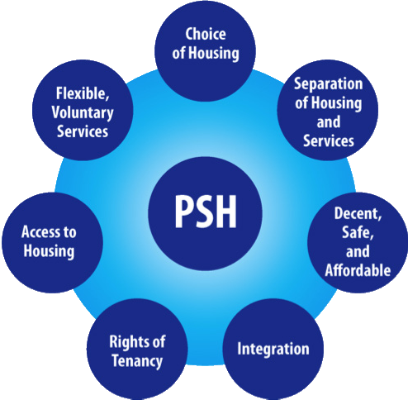

Choice of Housing
The tenant has access to a range of housing choices and living arrangements sufficient to meet their preferences.
Separation of Housing and Services
There is a functional separation between the housing management and services staff.
Decent, Safe, and Affordable Housing
The housing is affordable based upon the tenant’s income and perspective, and the housing complies with the Quality Standards of the U.S. Department of Housing and Urban Development.
Housing Integration
The degree to which the person’s housing is incorporated into the community or clustered with other persons with disabilities
Rights of Tenancy
The tenant has full legal rights as defined by local tenant/landlord laws and tenancy is not based upon program rules or treatment participation
Access to Housing
A person’s access is not dependent upon a demonstration of housing readiness, limited by their barriers to housing, and respects the tenant’s privacy.
Flexible, Voluntary, Services
The person has a choice of an array of adaptive and scale-able services that meet their needs. These services should be consumer-driven, recovery-oriented, and evidence-based

